**PRACTICAL 1: INTRODUCTION AND CONTRIBUTION TO WIKIPEDIA.**

**A] Description about Wikipedia and its features.**

**Description** is the pattern of narrative development that aims to make vivid a place, object, character, or group. Description is one of four [rhetorical modes](https://en.wikipedia.org/wiki/Rhetorical_modes) (also known as modes of discourse), along with [exposition](https://en.wikipedia.org/wiki/Exposition_(literary_technique)), [argumentation](https://en.wikipedia.org/wiki/Argumentation_theory), and [narration](https://en.wikipedia.org/wiki/Narration). In practice it would be difficult to write literature that drew on just one of the four basic modes.

Jimmy Wales and Larry Sanger co-founded Wikipedia as an offshoot of an earlier encyclopedia project, Nupedia, in January 2001. Originally, Wikipedia was created to provide content for Nupedia. However, as the wiki site became established it soon grew beyond the scope of the earlier project. As of January 2015, the website provided well over five million articles in English and more than that number in all other languages combined. At that same time, Alexa ranked Wikipedia as the seventh-most popular site on the Internet. Wikipedia was the only non-commercial site of the top ten.

Criticisms of Wikipedia include assertions that its openness makes it unreliable and unauthorative. Because articles don't include bylines, authors aren't publicly accountable for what they write. Similarly, because anyone can edit any article, the site's entries are vulnerable to unscrupulous edits. In August 2007, Virgil Griffiths created a site, [WikiScanner](https://whatis.techtarget.com/definition/WikiScanner), where users could track the sources of edits to Wikipedia entries. Griffiths reported that self-serving edits typically involved whitewashing or removal of criticism of a person or organization or, conversely, insertion of negative comments into the entry about a competitor. Wikipedia depends upon the vigilance of editors to find and reverse such changes to content.

In addition to the encyclopedia, the non-profit Wikipedia foundation oversees several other open-content projects, including:

* Wiktionary, a dictionary and thesaurus
* Wikibooks, a collection of free texts and other books
* Wikiquote, a collection of quotations
* Wikisource, a collection of free source documents
* Wikiversity, a collection of free learning materials
* Wikispecies, a directory of species
* Meta-Wiki, which coordinates all the other projects.

Wikipedia was one of the first [social media](https://whatis.techtarget.com/definition/social-media) websites.

**B] Creating Account on Wikipedia.**

* Step 1:

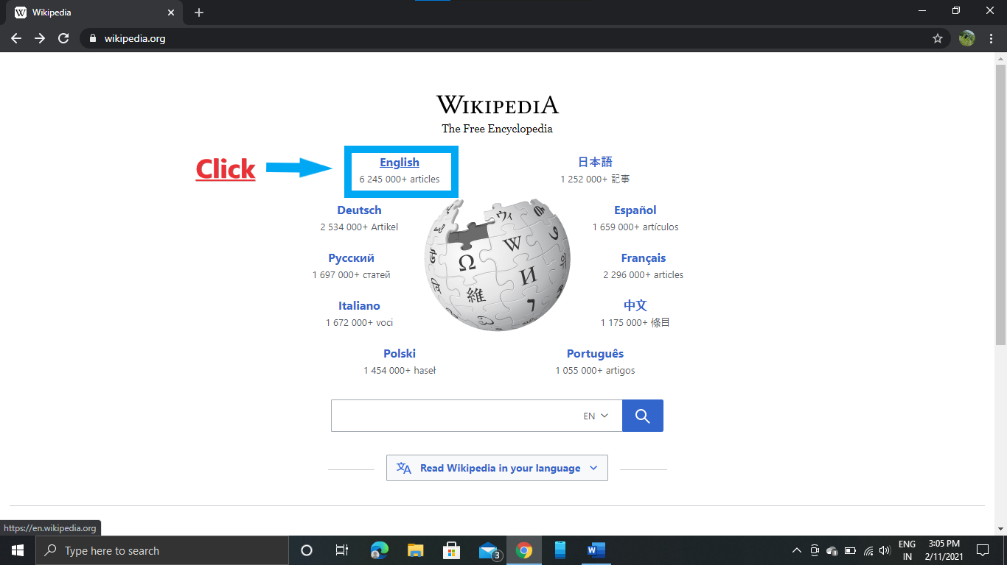

* Step 2:

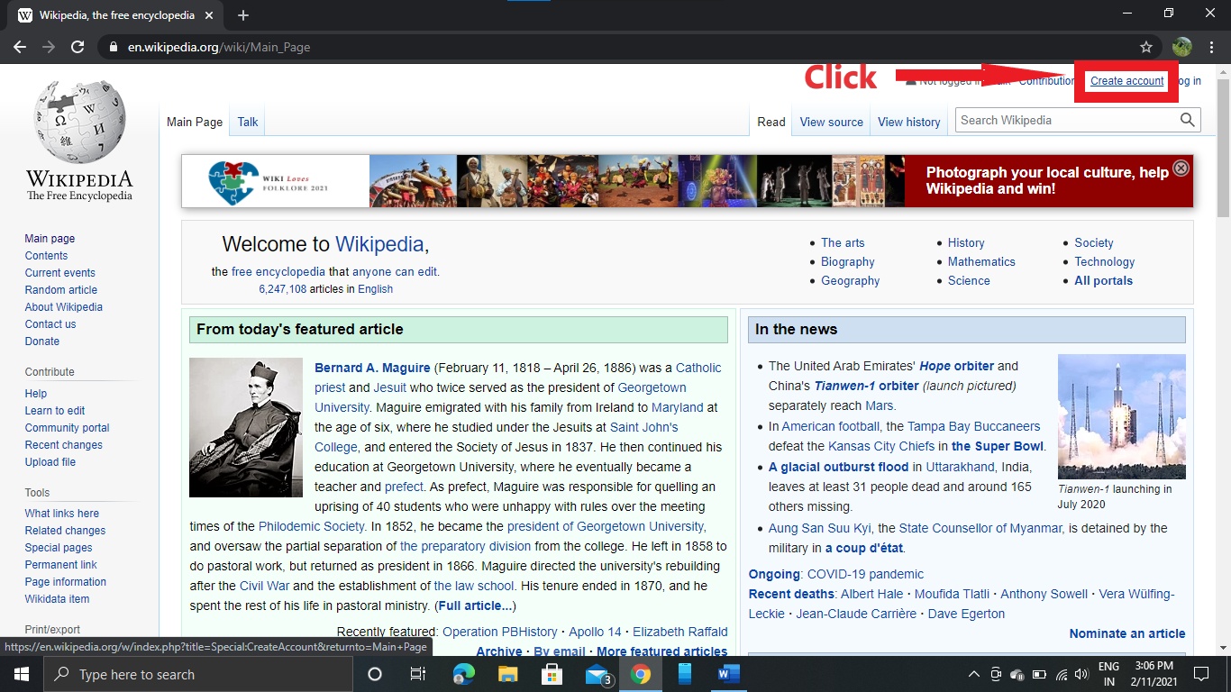

* Step 3:

Fill all required data.(Usename, Password, Email Id,)and type the captcha and click CREATE YOUR ACOOUNT. 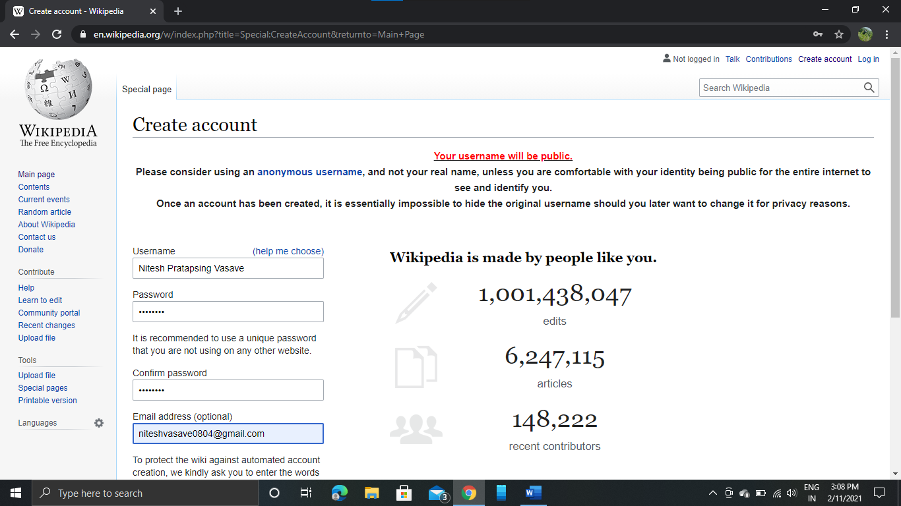

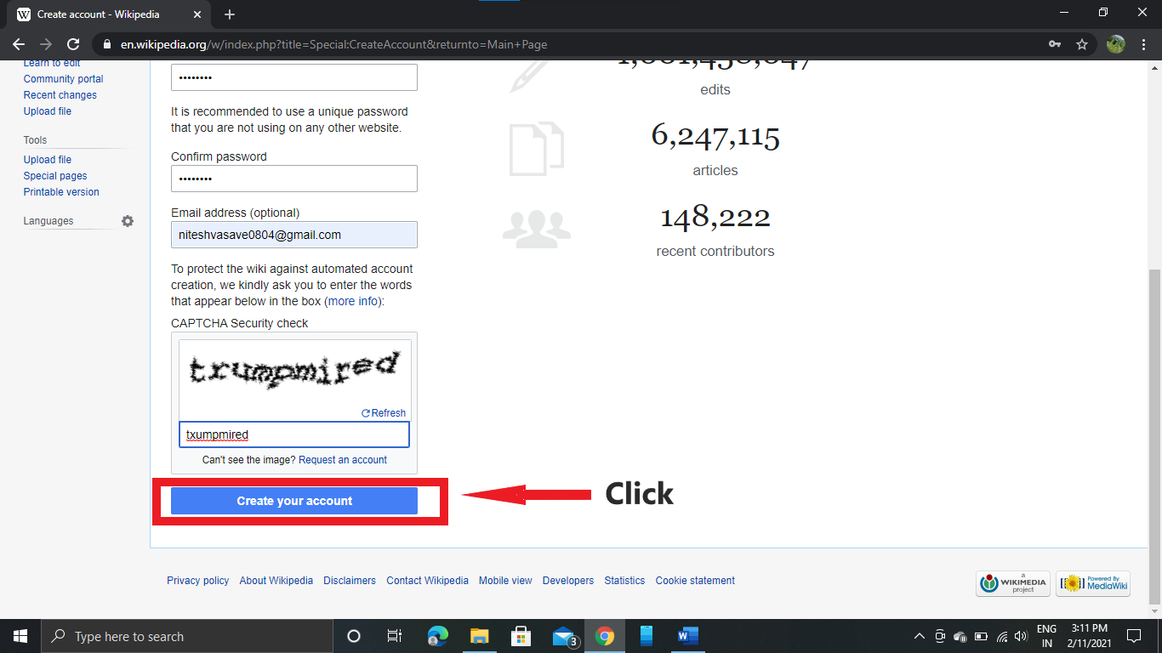

* Your Account is Created:

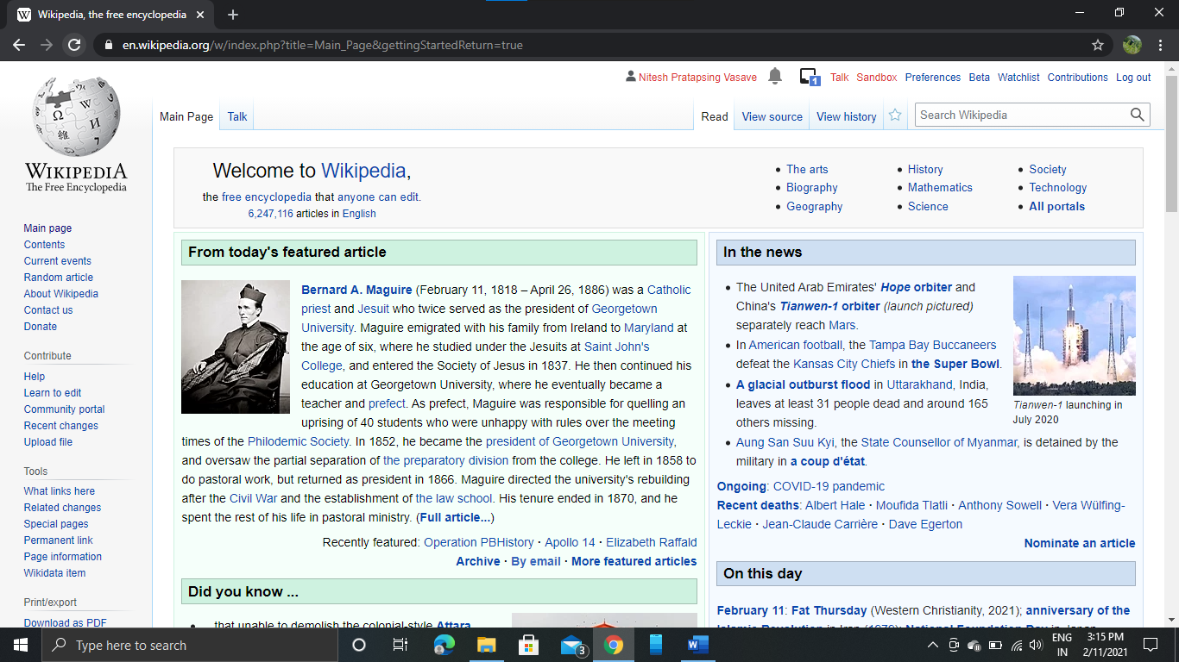

* **Creating your page on Wikipedia.**

**1)Search Your Name:**

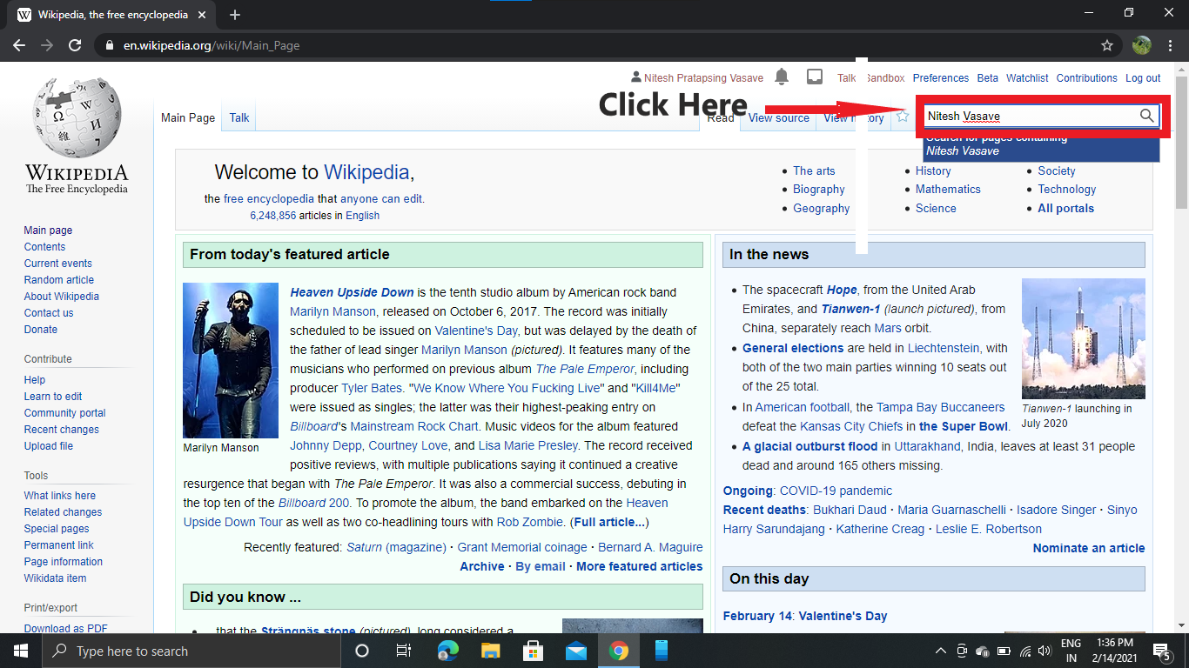

**2)** 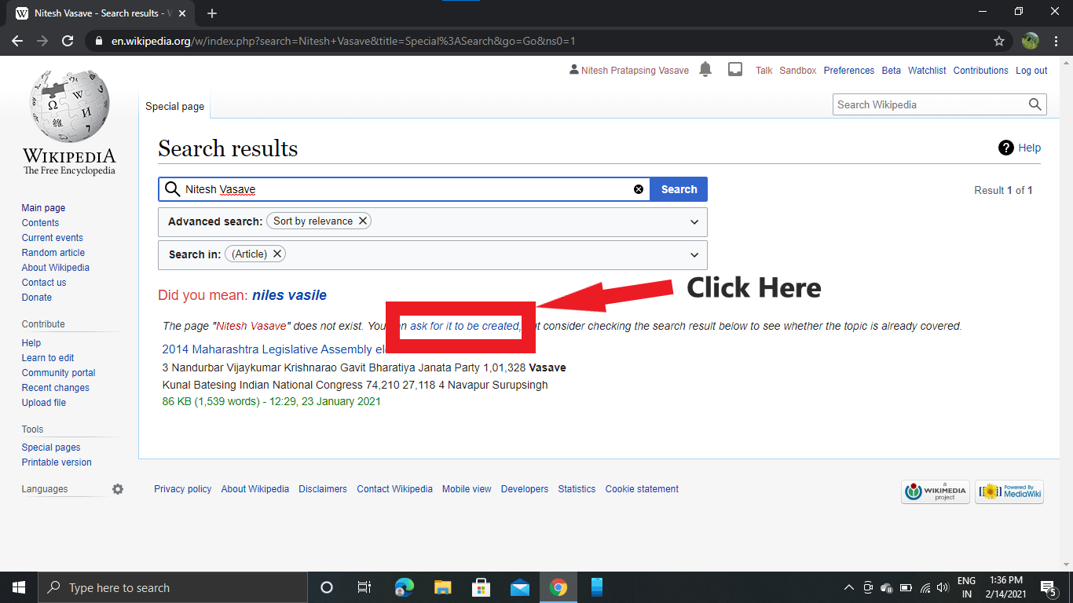

**3)**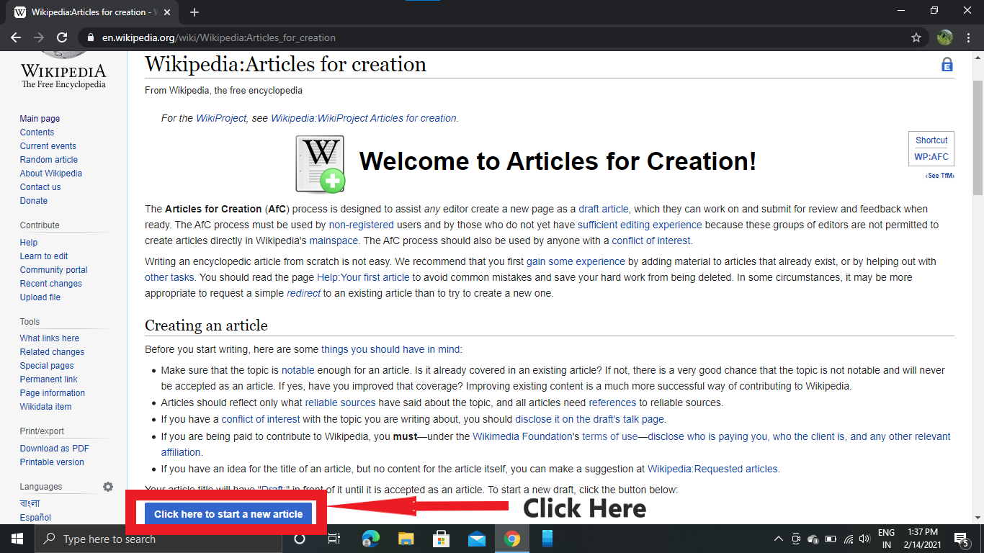

**4)**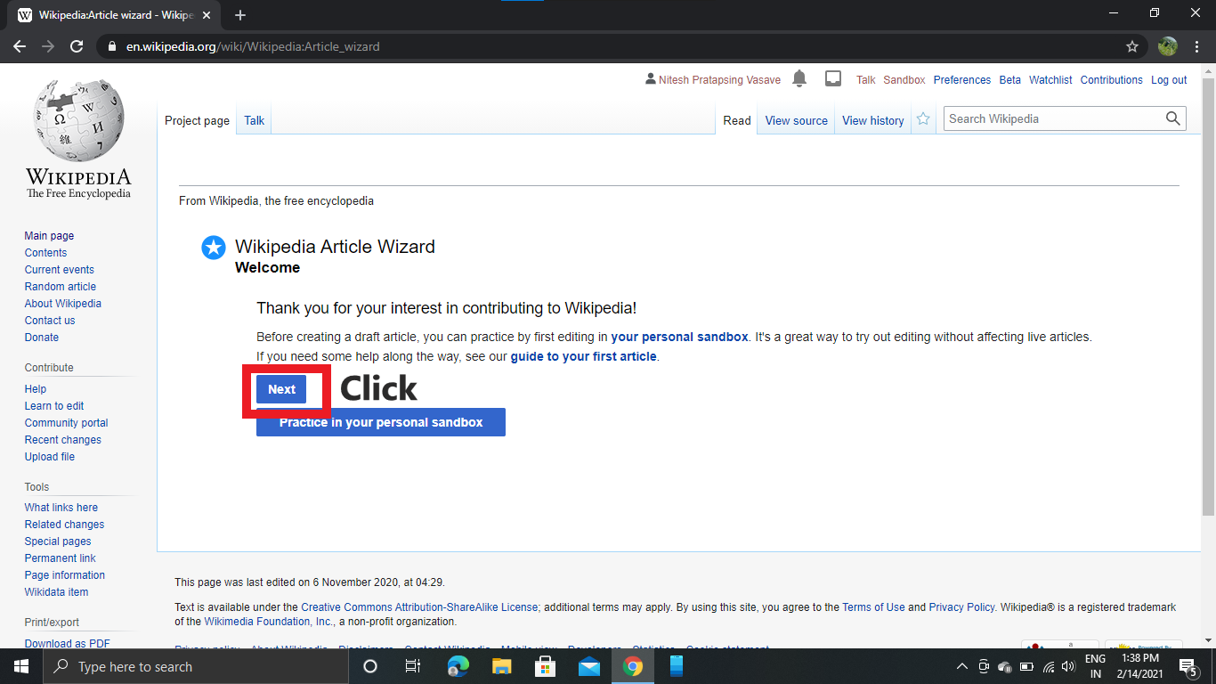

5)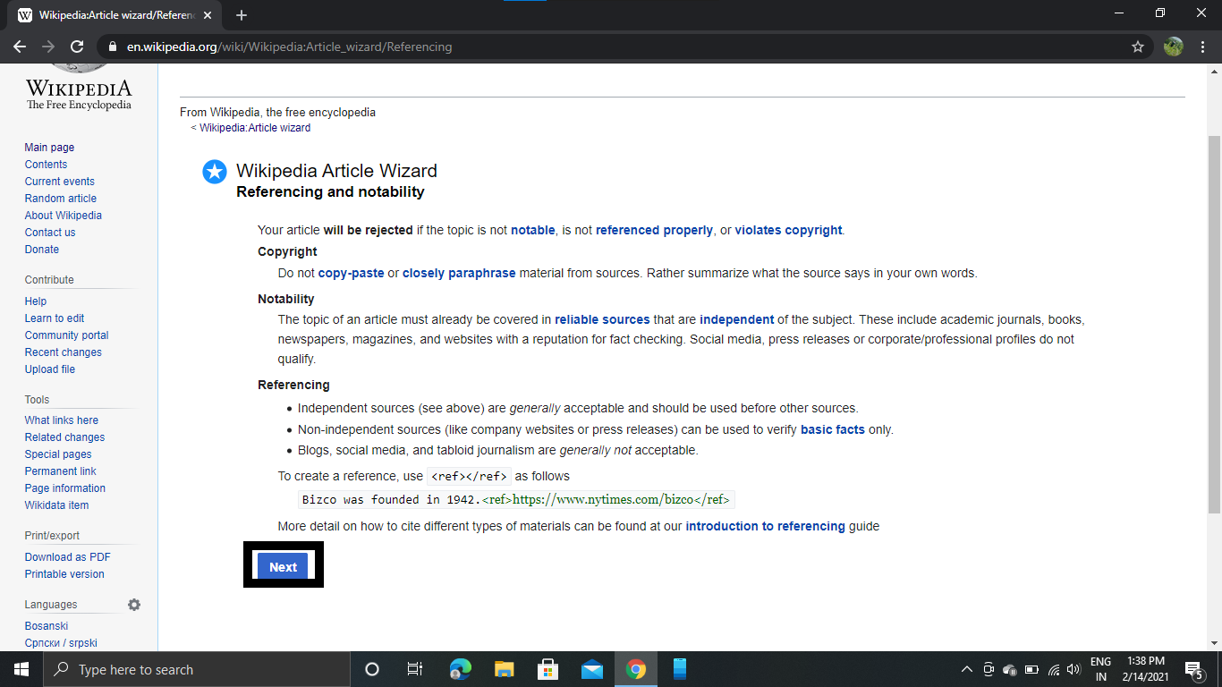

6)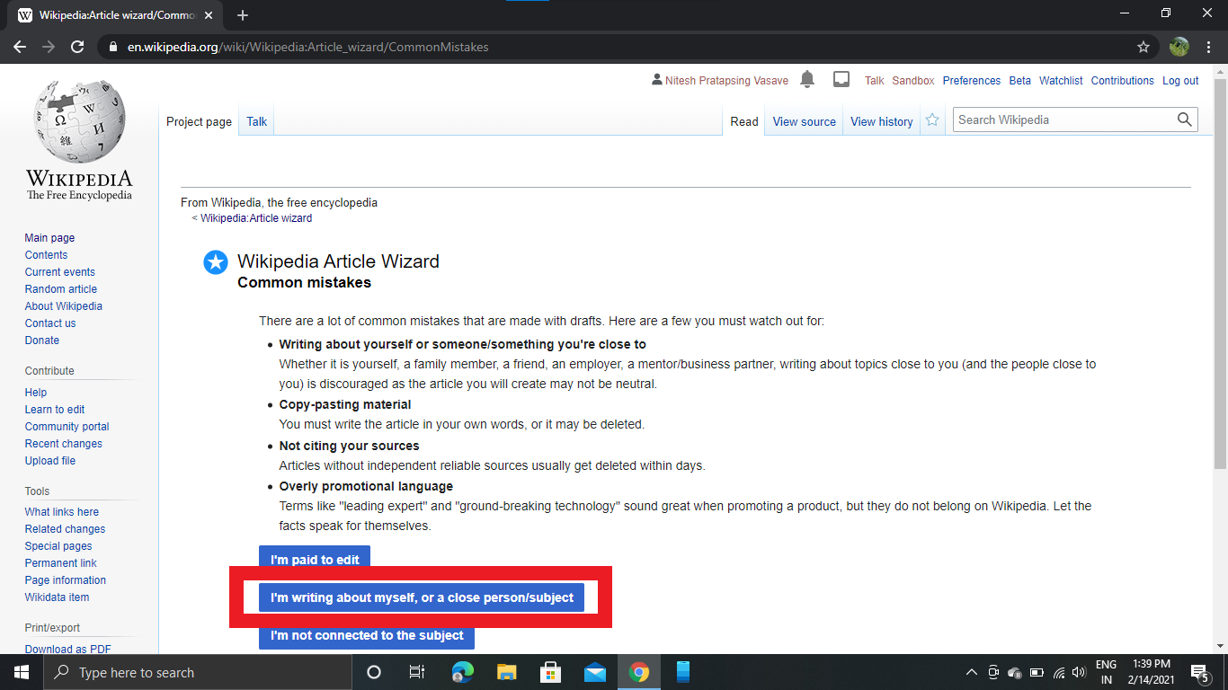

7)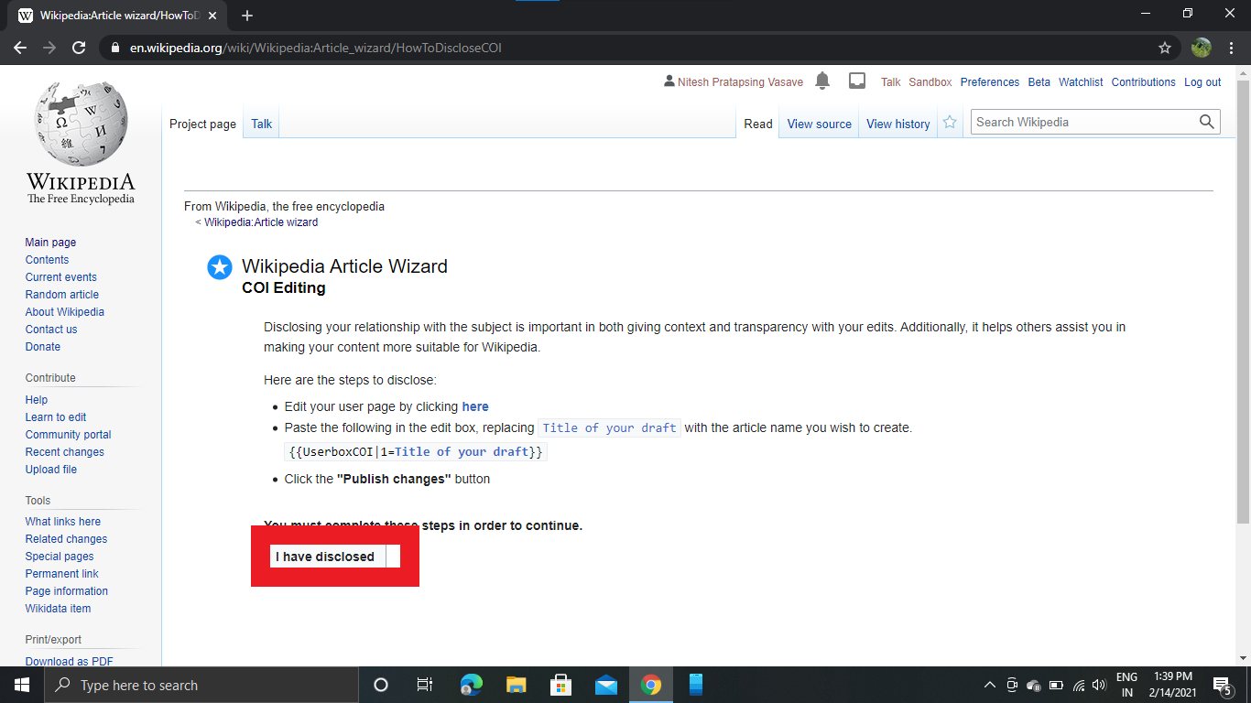

8)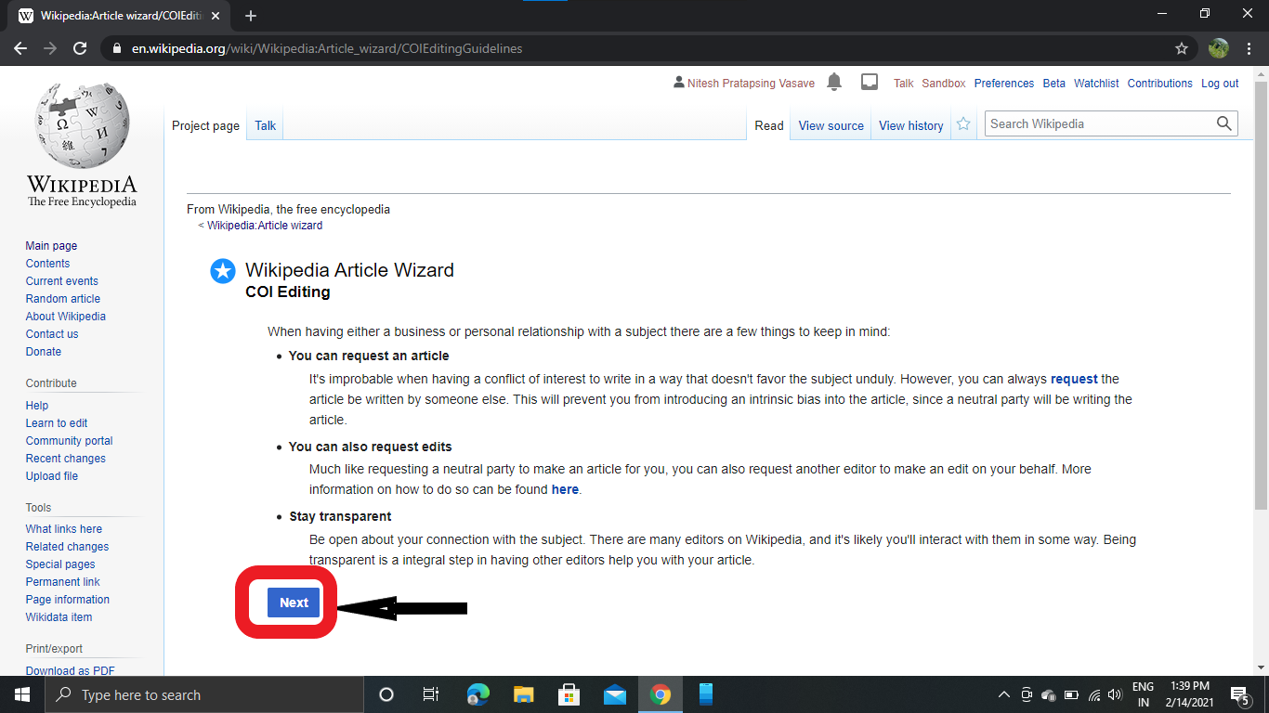

9

9) Type your page title in text box and click create new article.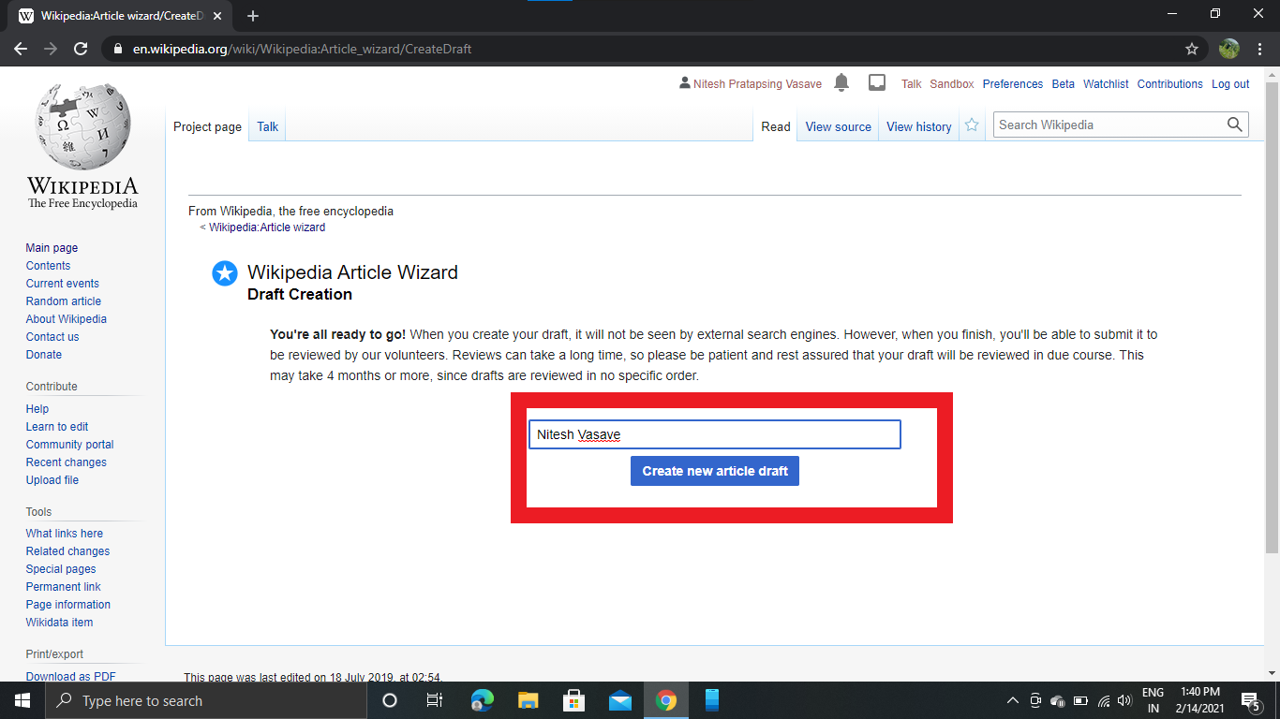

10)Now you can type whatever you want to in your page.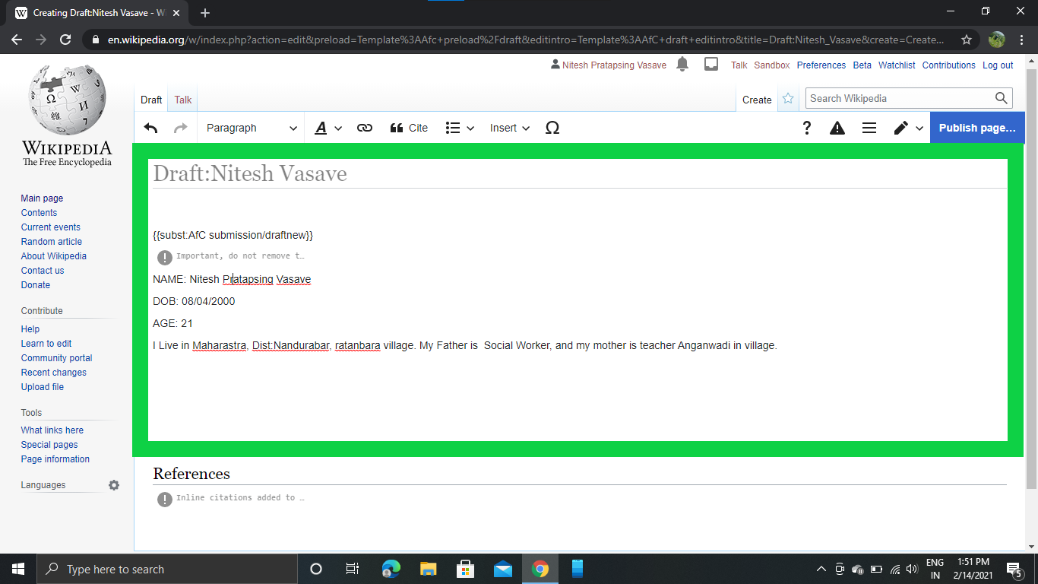

11)When you Click Publish Page ,One Box is displayed.Filled this box and Click Publish page.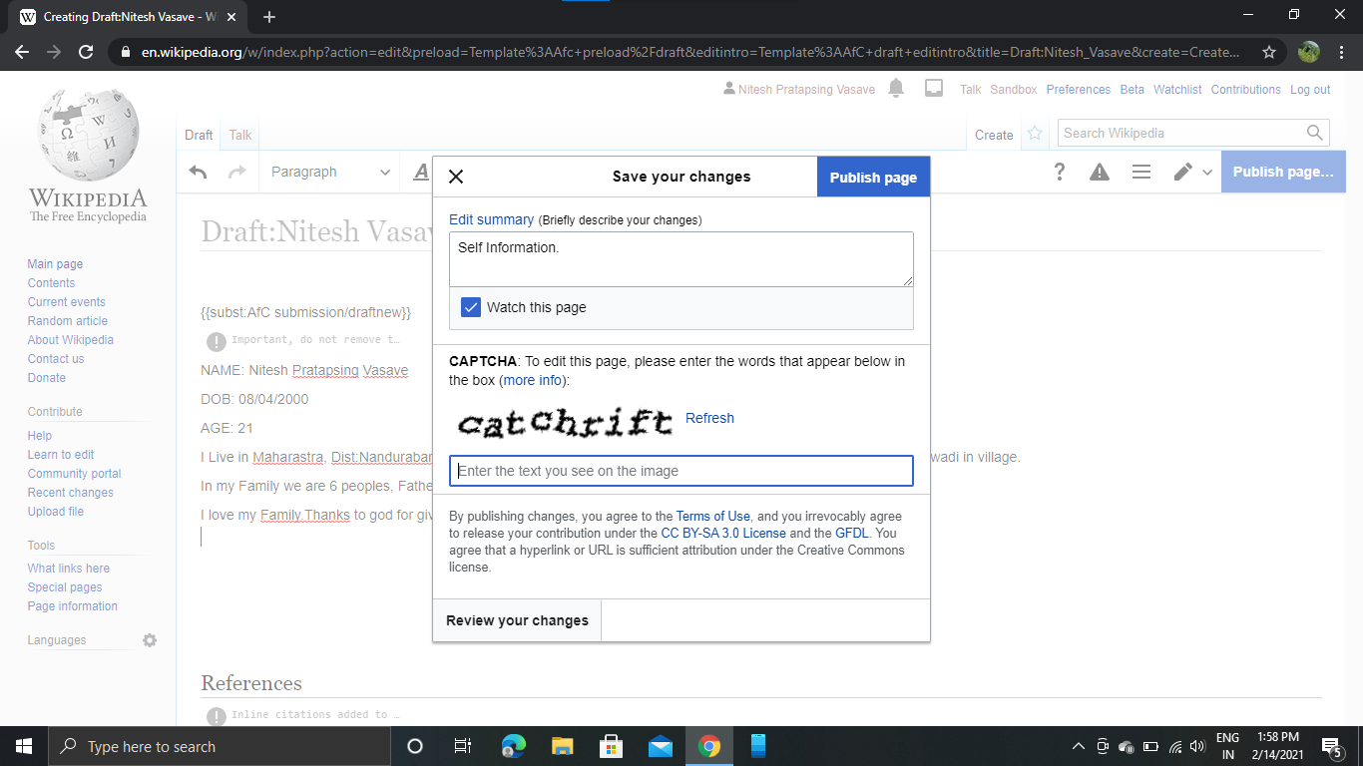

12) Click Below Button For review your page .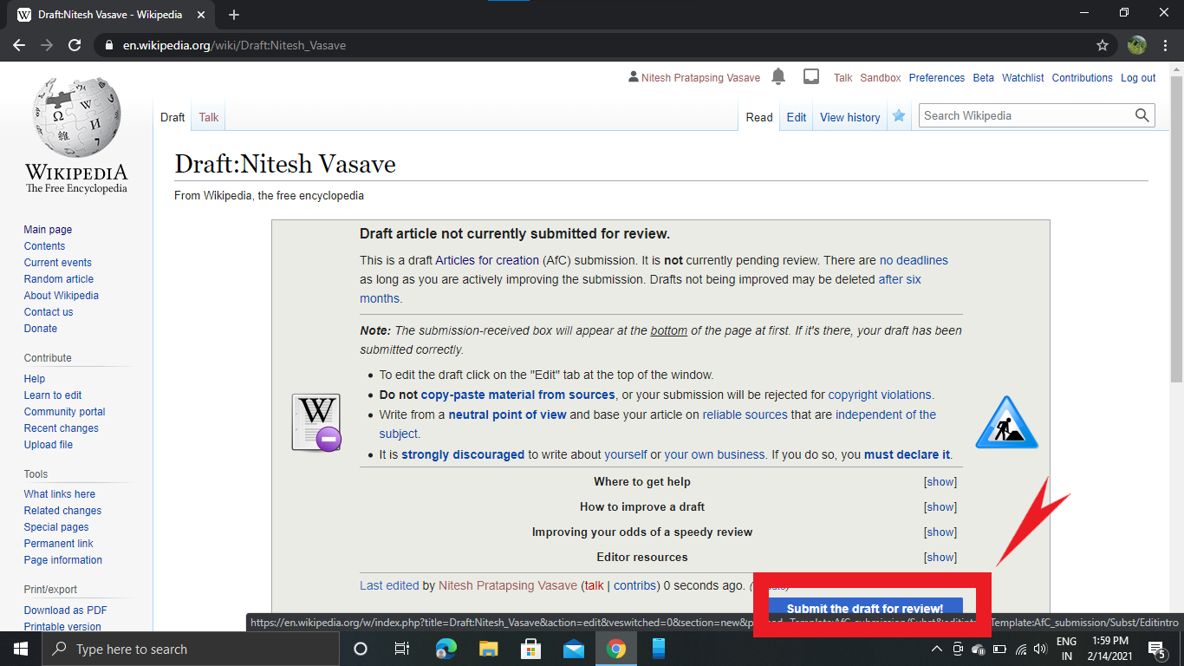

13)After review Click Publish Page.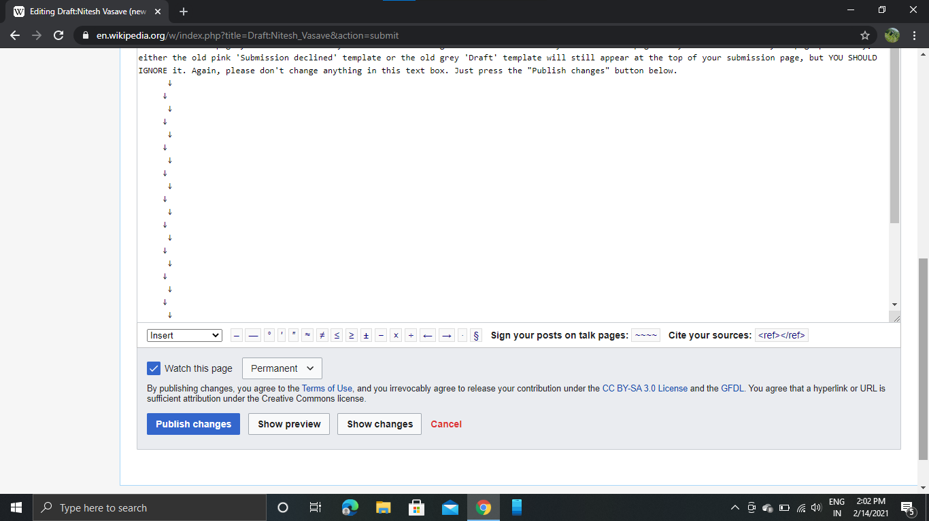

14)Your Page is Created.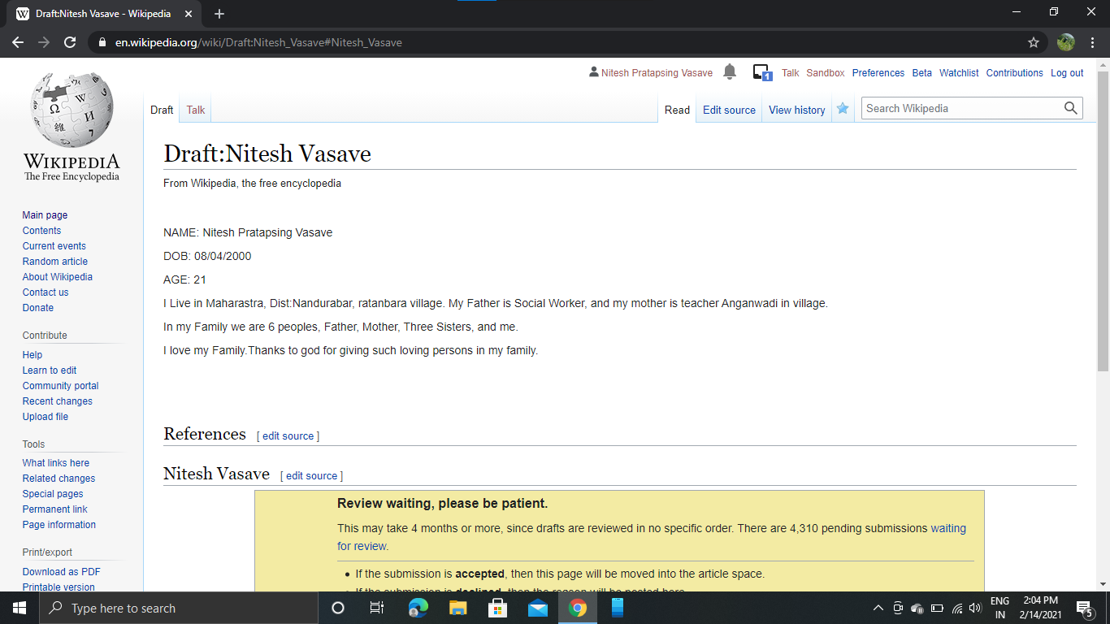

**D] Editing Your Page:**

**1) Click Edit Source**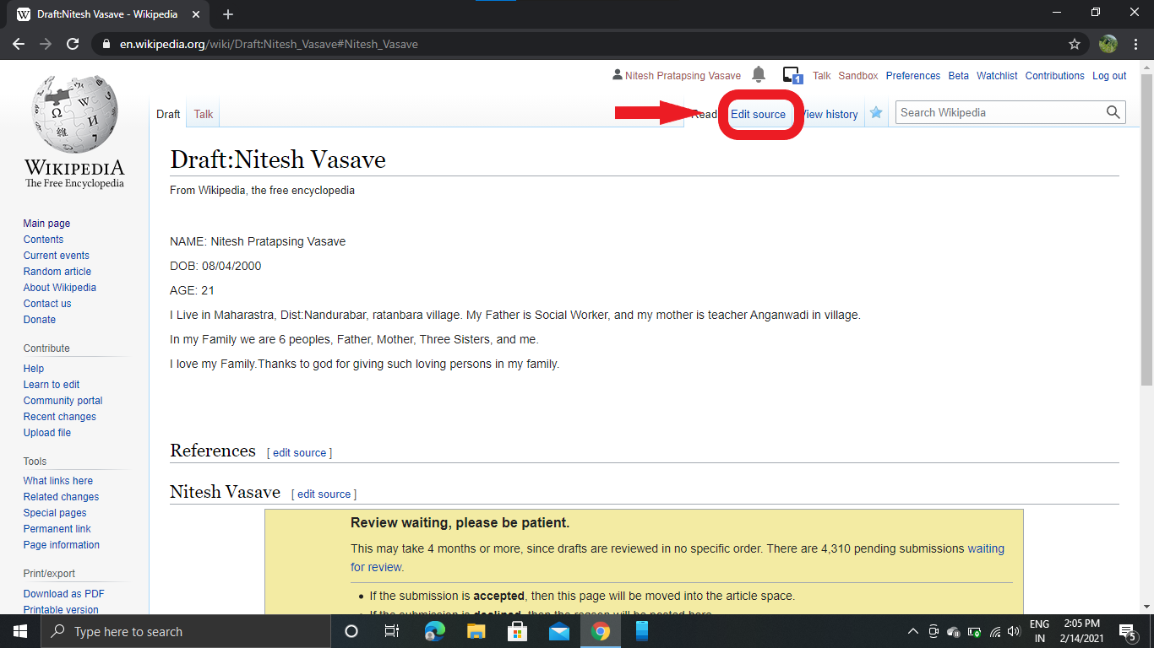

2) Edit Your Information:, and fill Summary box,after editing Click Publish Page.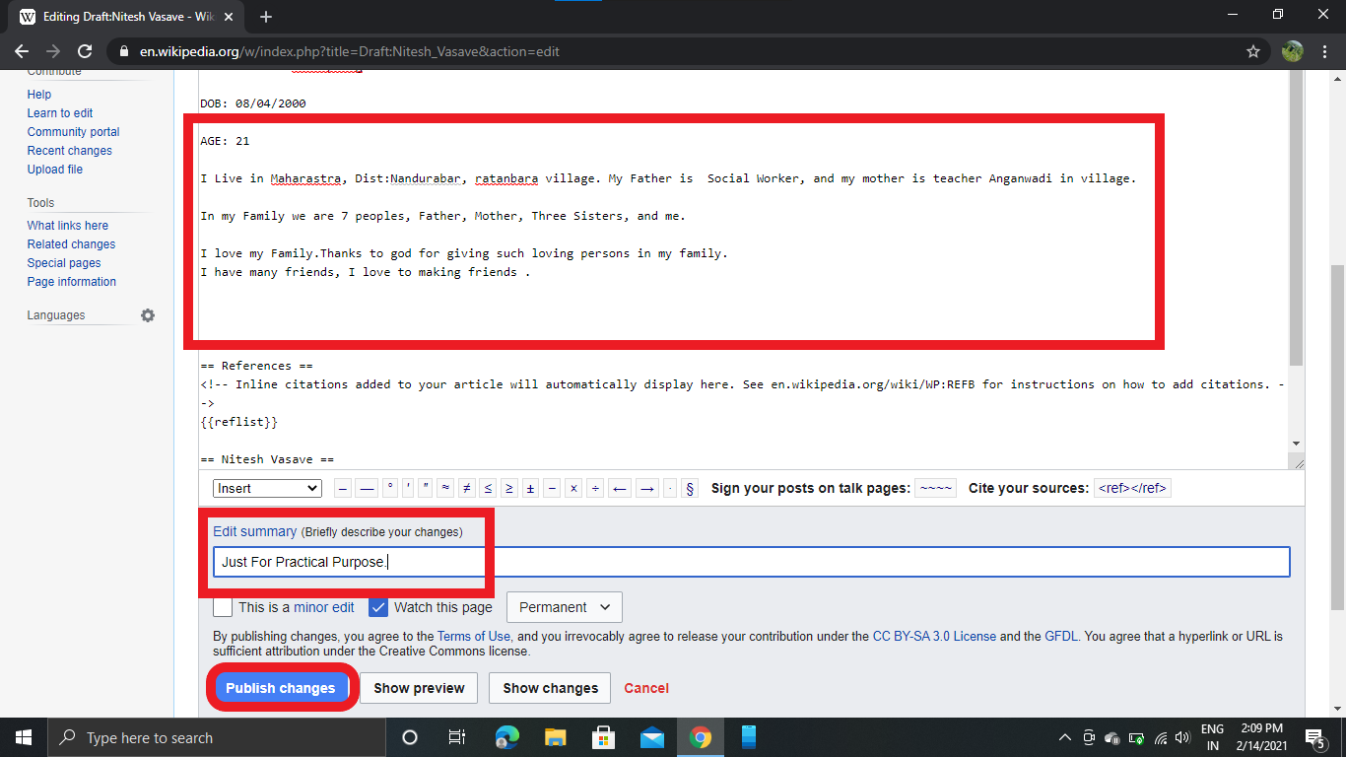

3)Your Page is Edited.